
SCHOOL OF COMPUTING
Department of Artificial Intelligence and Machine Learning
BANK ACCOUNT MANAGEMENT SYSYEM
A Capstone Project Report
BATCH NUMBER : 3
Submitted in partial fulfillment of the requirements for the award of the degree of
BACHELOR OF TECHNOLOGY
in
ARTIFICIAL INTELLIGENCE AND MACHINE LEARNING
Submitted by
Y. JASWANTH - AIML | (25B11AIC83)
- PRASANNA KUMAR - AIML | (26B61AI072)
K. PRASANNAKUMAR - AIML | (25B11AI488)
K. MURALI KRISHNA - AIML | (25B11AI518)

Under the guidance of
Dr. P. Kishorekumar, PhD.
Associate Professor, Department of AIML
ADITYA UNIVERSITY, SURAMPALEM
Academic Year: 2026 - 2027

SCHOOL OF COMPUTING
Department of Artificial Intelligence and Machine Learning
CERTIFICATE
This is to certify that the Capstone project work entitled "BANK ACCOUNT MANAGEMENT SYSTEM" is submitted by
Y. JASWANTH - AIML | (25B11AIC83) |  | (25B11AI006)
K. PRASANNA KUMAR - AIML | (26B61AI072) |  | (26B61AI002)
K. PRASANNAKUMAR - AIML | (25B11AI488) |  | (25B11AI218)
K. MURALI KRISHNA - AIML | (25B11AI518) |  | (25B11AI116)

In partial fulfillment of the requirements for the award of the B.Tech. degree in Artificial Intelligence and Machine Learning for the academic year 2026-2027.

Project Guide  Dr. P. Kishorekumar, PhD.  Associate Professor, Department of AIML | Head of the Department:  Dr. Kovvuri N Bhargavi  Associate Professor & HOD

DECLARATION
We hereby declare that the Capstone project entitled "BANK ACCOUNT MANAGEMENT SYSTEM" is original and is submitted to ADITYA UNIVERSITY, Surampalem, in partial fulfillment of the requirements for the award of the B.Tech. Degree in Artificial Intelligence and Machine Learning. We further declare that this project work has not been submitted, either in full or in part, for the award of any degree in this or any other institution. We also confirm that this work complies with the Institutional Academic Integrity and AI Usage Policy.
Place: Surampalem
Date:30-09-2026
By

Y. JASWANTH - AIML | (25B11AIC83) |  | (25B11AIC83)
K. PRASANNA KUMAR - AIML | (26B61AI072) |  | (26B61AI072)
K. PRASANNAKUMAR - AIML | (25B11AI488) |  | (25B11AI488)
K. MURALI KRISHNA - AIML | (25B11AI518) |  | (25B11AI518)

ACKNOWLEDGEMENT
It is with immense pleasure that we express our sincere gratitude to our Capstone Project Guide, Dr. P. Kishorekumar, PhD. Associate Professor, Department of AIML, who has guided us throughout the project. His valuable support, encouragement, and guidance have greatly contributed to the successful completion of this work.
We would like to thank our Deputy Heads of the Department, Dr. B. Manikyala Rao, Associate Professor, Dr. R. Suneetha, Assistant Professor and Dr. D. Veeraswamy, Assistant Professor for their support and valuable suggestions.
Our deepest thanks to our Head of the Department Dr. K. Naga Bhargavi, Associate Professor & HOD, for her inspiration and for providing all the necessary facilities and resources required for this project.
We also extend our sincere thanks to Dr. M.V. Rajesh, Associate Dean, School of Computing for their encouragement and support during the course of our project.
We would like to express our sincere gratitude to Dr. G. Suresh, Registrar, Dr. A. Ramesh, Pro Vice-Chancellor (Engineering & Sciences), Dr. S. Rama Sree, Pro Vice-Chancellor (Academics), Dr. M.B. Srinivas, Vice-Chancellor, Dr. M. Sreenivasa Reddy, Deputy Pro Chancellor and Management, Aditya University for providing excellent infrastructure and state-of-the-art laboratories.
Finally, we would like to thank the faculty members, lab technicians, non-teaching staff, and our friends who have directly or indirectly supported us in completing this Capstone project successfully.

By
Y. JASWANTH - AIML | (25B11AIC83) |  | (25B11AI006)
K. PRASANNA KUMAR - AIML | (26B61AI072) |  | (26B61AI002)
K. PRASANNAKUMAR - AIML | (25B11AI488) |  | (25B11AI218)
K. MURALI KRISHNA - AIML | (25B11AI518) |  | (25B11AI116)

TABLE OF CONTENTS
1. Table of contents 1
2. Abstract 2
3. List of Figures / List of Tables / Acronyms 3
4. Introduction 5
5. System Analysis 7
6. Database Design 10
7. ER Diagram 12
8. Relational Schema 14
9. Table Design 15
10. Normalization 18
11. SQL Implementation 20
12. SQL Queries & Screenshots 25
13. Conclusion & Future Enhancements 38
14. References 39

ABSTRACT
- The Bank Account Management System is designed to organize and manage the large volume of banking information handled by a bank. Banking systems routinely deal with data relating to customers, accounts, branches, employees, transactions, and loans. Maintaining such records manually or across separate files can lead to duplicate data, difficulty in searching records, and errors in maintaining transaction and account information. The proposed system models the major banking entities and the relationships between them using a relational database approach and stores the information in a centralized database. Primary Keys, Foreign Keys, and other constraints are used to maintain data integrity and consistency.
- The database has been designed with six major entities — Customer, Account, Branch, Employee, Transaction, and Loan — connected through well-defined one-to-many relationships. A customer may hold multiple accounts, a branch may manage multiple accounts and employees, an account may have multiple transactions, and a customer may have multiple loans. The database design is normalized up to the Third Normal Form (3NF) to reduce data redundancy and avoid update anomalies. The system has been implemented using SQL, covering Data Definition Language (DDL) for creating database structures, Data Manipulation Language (DML) for inserting, updating, and deleting records, and Data Query Language (DQL) for retrieving and analyzing information. The system also demonstrates joins, aggregate functions, CRUD operations, views, and data validation using constraints. The resulting design provides a structured foundation for customer management, account management, branch and employee management, transaction tracking, loan management, and efficient banking data retrieval and reporting.

LIST OF FIGURES
Figure 1. ER Diagram of the Bank Account Management System

LIST OF TABLES
- Table 1. Major Database Entities
- Table 2. Entity Relationships and Cardinality
- Table 3. Relational Schema Summary
- Table 4. Customer Table Structure
- Table 5. Account Table Structure
- Table 6. Branch Table Structure
- Table 7. Employee Table Structure
- Table 8. Transaction Table Structure
- Table 9. Loan Table Structure
- Table 10. Keys and Constraints Summary
- Table 11. Normalization up to Third Normal Form (3NF)
- Table 12. SQL Operations and Query Categories
- Table 13. Database View Structure
- Table 14. Data Integrity and Validation Rules

ACRONYMS
- DBMS – Database Management System
- ER – Entity Relationship
- SQL – Structured Query Language
- DDL – Data Definition Language
- DML – Data Manipulation Language
- DQL – Data Query Language
- DCL – Data Control Language
- TCL – Transaction Control Language
- PK – Primary Key
- FK – Foreign Key
- 1NF – First Normal Form
- 2NF – Second Normal Form
- 3NF – Third Normal Form

1. INTRODUCTION
1.1 Brief Information about the Project
Banks handle large amounts of information related to customers, accounts, branches, employees, transactions, and loans. A database provides a structured and efficient way to organize and manage these interconnected banking records. The proposed Bank Account Management System models the major banking entities and their relationships using a relational database approach.
The project focuses on designing the database structure — including entities, attributes, Primary Keys, Foreign Keys, relationships, and the ER diagram — and implementing it through SQL. The system provides a centralized approach for managing customer information, account details, branch and employee records, transaction history, and loan information while maintaining data accuracy and consistency.

1.2 Motivation and Contribution of the Project
The project is motivated by the practical difficulties banks face when customer, account, transaction, branch, employee, and loan records are managed separately or manually. Maintaining these records without a centralized system can lead to data duplication, inconsistency, difficulty in retrieving information, and errors in maintaining banking records. A centralized relational database provides a systematic approach to storing related banking data and enforcing relationships through keys and constraints.
● Centralizing banking records — customers, accounts, branches, employees, Transactions, and loans in one relational database.
● Reducing duplicate and inconsistent information across different banking records.
● Maintaining referential integrity using Primary Keys and Foreign Keys.
● Supporting faster retrieval of customer, account, and transaction information through SQL queries.
● Providing a foundation for account management, transaction tracking, branch and employee management, and loan management.

1.3 Objectives of the Project
● Identify the major entities involved in bank account management.
● Identify suitable attributes for each entity.
● Establish relationships between the identified entities.
● Design an Entity–Relationship (ER) diagram.
● Convert the ER model into a relational database schema.
● Identify suitable Primary Keys and Foreign Keys.
● Reduce data duplication and maintain data consistency through normalization and constraints.
● Provide an organized database structure for efficient management of customer, account, branch, employee, transaction, and loan records.

1.4 Scope of the Project
The scope of the project covers the database-oriented management of core banking information. The system connects customer personal and contact information (Customer), account number, account type, balance and account status (Account), branch name, IFSC code, address and city (Branch), employee details, designation and branch assignment (Employee), account transactions including transaction type, amount, date and status (Transaction), and customer loan information including loan type, loan amount and interest rate (Loan).
The database can serve as the backend for a banking administration application and can be extended with modules such as online banking integration, mobile application support, fund transfer, loan repayment and tracking, reports and analytics, user authentication, backup and recovery, and audit logging.

2. SYSTEM ANALYSIS

2.1 Existing System
● Manual or paper-based maintenance of customer, account, and transaction records.
● Multiple Excel sheets or disconnected files for customers, accounts, branches, employees, and loans.
● Duplicate records and inconsistent information across different banking records.
● Time-consuming searches for customer details, account information, or previous transactions.
● Difficulty in generating consolidated reports for banking administration and analysis.
● Higher possibility of data-entry errors and difficulty in maintaining accurate and consistent records.

2.2 Proposed System
The proposed system uses a centralized relational database that connects banking records through well-defined entities, relationships, Primary Keys, and Foreign Keys. It organizes banking information into related tables and uses primary keys, foreign keys, uniqueness rules, NOT NULL conditions, and CHECK constraints to maintain valid and consistent data.
● Centralized banking database with six major entities.
● Customer registration and record management.
● Account and branch management.
● Employee and branch assignment management.
● Transaction recording and transaction history management.
● Loan information and customer loan management.
● SQL-based data retrieval, analysis, and reporting.
● CRUD operations for managing database records.
● Referential integrity across all related tables using Primary and Foreign Keys

2.3 Functional Requirements
Module | Functional Requirement
Customer Management | Add, view, update, and manage customer details.
Account Management | Store and manage account number, account type, balance, opening date, and account status.
Branch Management | Maintain branch details such as branch name, IFSC code, address, and city.
Employee Management | Store employee details, designation, contact information, and assigned branch.
Transaction Management | Record deposits and withdrawals with transaction type, amount, date, and status.
Loan Management | Maintain loan type, loan amount, interest rate, and customer loan details.
Data Retrieval & Analysis | Maintain prescriptions with dosage, linked to a patient, doctor, and medicine.
Search and Reporting | Retrieve and analyze banking information using SQL queries, joins, aggregate functions, GROUP BY, and HAVING.
Search and Reporting | Retrieve customer, account, branch, transaction, and loan information and generate useful reports using SQL queries.

2.4 Non-Functional Requirements
● Performance – queries on customer, account, transaction, and loan data should return results efficiently.
● Integrity – invalid references and duplicate key values must be prevented using Primary Keys, Foreign Keys, and constraints.
● Security – access to sensitive customer, account, transaction, and loan information should be controlled for authorized users.
● Usability – the database structure should be understandable and easy for banking staff to use.
● Reliability – database operations such as account updates and transactions should preserve a consistent database state.
● Scalability – the design should support growth in customers, accounts, transactions, branches, employees, and loan records over time.

2.5 Requirements Specification
Category | Requirement
Hardware | Intel i3 or above; 4 GB RAM minimum; adequate storage; standard display and keyboard/mouse.
Operating System | Windows 10/11 or an equivalent supported platform.
Database | MySQL Relational Database Management System.

3. DATABASE DESIGN

3.1 Major Entities
Six major entities have been identified for the proposed Bank Account Management System, as summarised in Table 1.
Table 1: Major Database Entities
Entity | Description
CUSTOMER | Stores customer details, date of birth, gender, phone, email, and address.
ACCOUNT | Stores account number, account type, balance, opening date, status, and customer/branch references.
BRANCH | Stores branch name, IFSC code, address, and city.
EMPLOYEE | Stores employee name, designation, phone, and assigned branch.
TRANSACTION | Stores transaction type, amount, transaction date, account reference, and status.
LOAN | Stores loan type, loan amount, interest rate, and customer reference.

3.2 ER Model
The ER model represents the major banking entities and the relationships between them. CUSTOMER is related to ACCOUNT and LOAN, where a customer may have multiple accounts and loans. BRANCH is related to both ACCOUNT and EMPLOYEE, where a branch can manage multiple accounts and employees. ACCOUNT is related to TRANSACTION, where an account may have multiple transaction records. These relationships establish the connections between customers, accounts, branches, employees, transactions, and loans and form the basis of the Bank Account Management System database

3.3 Relationships and Cardinality
Table 2: Entity Relationships and Cardinality
Relationship | Cardinality | Meaning
CUSTOMER – ACCOUNT | 1: M | One customer can have many accounts.
BRANCH – ACCOUNT | 1: M | One branch can have many accounts.
BRANCH – EMPLOYEE | 1: M | One branch can have many employees.
ACCOUNT – TRANSACTION | 1: M | One account can have many transaction records.
CUSTOMER – LOAN | 1: M | One customer can have many loans.

4. ER DIAGRAM
Figure 1: ER Diagram of the Bank Account Management System (SOFTWARE BASED)
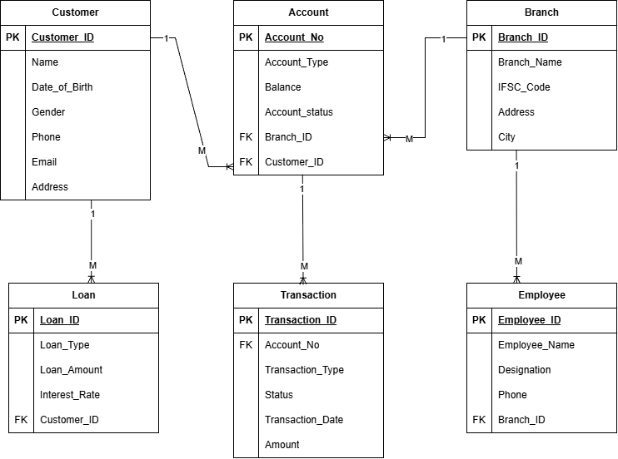
The ER diagram shows the six entities of the Bank Account Management System and the one-to-many relationships between them. Primary Keys (PK) and Foreign Keys (FK) are marked within each entity box, consistent with the relational schema and the SQL implementation presented in the following sections.

Figure 2: ER Diagram of the Bank Account Management System (MANUAL)

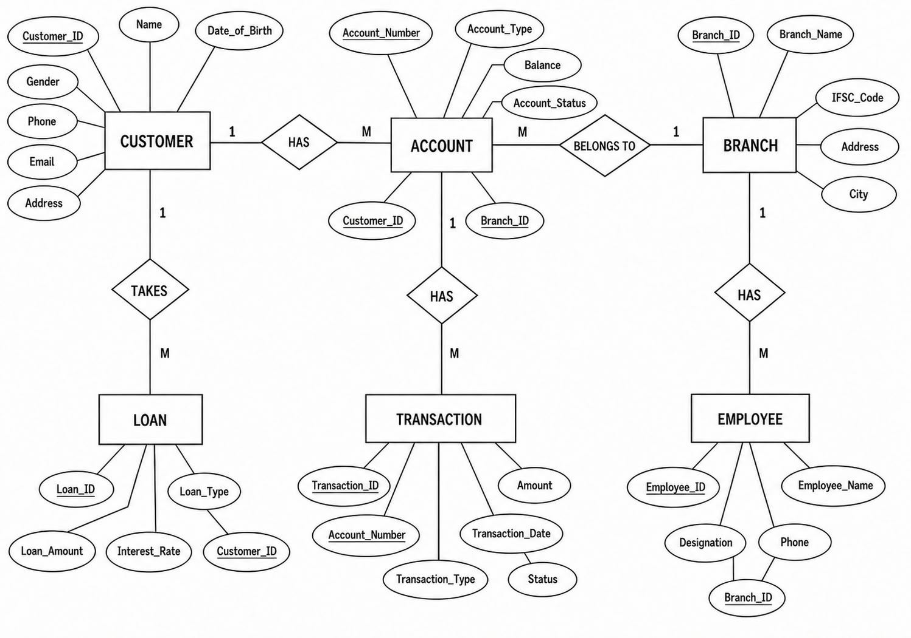

5. RELATIONAL SCHEMA
The relational schema below follows the table-creation order used in the SQL implementation, so that every Foreign Key (FK) references a valid parent table that has already been defined.
Table 3: Relational Schema Summary
Relation | Relational Schema | Keys
CUSTOMER | Customer (Customer_ ID, Name, Date_ of_ Birth, Gender, Phone, Email, Address) | PK: Customer_ ID
BRANCH | Branch (Branch_ ID, Branch_ Name, IFSC_ Code, Address, City) | PK: Branch_ ID
ACCOUNT | Account (Account_ Number, Account_ Type, Balance, Opening_ Date, Account_ Status, Customer_ ID, Branch_ ID) | PK: Account_ Number;  FK: Customer_ ID, FK: Branch_ ID
EMPLOYEE | Employee (Employee_ ID, Employee_ Name, Designation, Phone, Branch_ ID) | PK: Employee_ ID; FK: Branch_ ID
TRANSACTION | Bank_ Transaction (Transaction_ ID, Account_ Number, Transaction_ Type, Amount, Transaction_ Date, Status) | PK: Transaction_ ID; FK: Account_ Number
LOAN | Loan (Loan_ ID, Loan_ Type, Loan_ Amount, Interest_ Rate, Customer_ ID) | PK: Loan_ ID;  FK: Customer_ ID

The Account relation references Customer and Branch; Employee references Branch; Bank_ Transaction references Account; and Loan references Customer. These Foreign Key relationships maintain referential integrity between the six entities of the Bank Account Management System.

6. TABLE DESIGN

6.1 Customer Table
Table 4: Customer Table Structure
Attribute | Data Type | Constraint | Description
Customer_ ID | INT | PK | Unique customer identifier
Name | VARCHAR (100) | NOT NULL | Name of the customer
Date_ of_ Birth | DATE | NOT NULL | Customer's date of birth
Gender | VARCHAR (10) | — | Gender of the customer
Phone | VARCHAR (15) | NOT NULL | Customer contact number
Email | VARCHAR (100) | UNIQUE | Customer email address
Address | VARCHAR (200) | — | Customer residential address

6.2 Account Table
Table 5: Account Table Structure
Attribute | Data Type | Constraint | Description
Account_ Number | INT | PK | Unique account number
Account_ Type | VARCHAR (20) | NOT NULL | Type of bank account
Balance | DECIMAL (12,2) | DEFAULT 0, CHECK (Balance >= 0) | Current account balance
Account_ Status | VARCHAR (20) | DEFAULT 'Active' | Current status of the account
Customer_ ID | INT | FK | Reference to the customer who owns the account
Branch_ ID | INT | FK | Reference to the branch where the account is maintained

6.3 Branch Table
Table 6: Branch Table Structure
Attribute | Data Type | Constraint | Description
Branch_ ID | INT | PK | Unique branch identifier
Branch_ Name | VARCHAR (100) | NOT NULL | Name of the bank branch
IFSC_ Code | VARCHAR (20) | UNIQUE, NOT NULL | Unique IFSC code of the branch
Address | VARCHAR (200) | — | Address of the branch
City | VARCHAR (50) | NOT NULL | City where the branch is located

6.4 Employee Table
Table 7: Employee Table Structure
Attribute | Data Type | Constraint | Description
Employee_ ID | INT | PK | Unique employee identifier
Employee_ Name | VARCHAR (100) | NOT NULL | Name of the bank employee
Designation | VARCHAR (50) | — | Designation or role of the employee
Phone | VARCHAR (15) | — | Employee contact number
Branch_ ID | INT | FK | References the Branch where the employee is assigned

6.5 Transaction Table
Table 8: Transaction Table Structure
Attribute | Data Type | Constraint | Description
Transaction_ ID | INT | P | Unique transaction identifier
Account_ Number | INT | FK | References the account associated with the transaction
Transaction_ Type | VARCHAR (20) | NOT NULL | Type of transaction
Amount | DECIMAL (12,2) | NOT NULL, CHECK (Amount > 0) | Amount involved in the transaction
Transaction_ Date | DATE | — | Date of the transaction
Status | VARCHAR (20) | — | Current status of the transaction

6.6 Loan Table
Table 9: Loan Table Structure
Attribute | Data Type | Constraint | Description
Loan_ ID | INT | PK | Unique loan identifier
Loan_ Type | VARCHAR (50) | NOT | Type of loan
Loan_ Amount | DECIMAL (12,2) | NOT NULL, CHECK (Loan_ Amount > 0) | Amount of the loan
Interest_ Rate | DECIMAL (5,2) |  | Interest rate applicable to the loan
  —
Customer_ ID | INT | FK | References the customer associated with the loan

7. NORMALIZATION
Normalization organizes data into related relations to reduce redundancy and update anomalies. The following example uses the Bank Account Management System entities—Customer, Account, Branch, Employee, Transaction, and Loan—to illustrate the normalization process from the Unnormalized Form (UNF) to the Third Normal Form (3NF). The final normalized structure reduces data duplication and improves data consistency and maintainability.

7.1 Unnormalized Form (UNF)
A single banking record might contain Customer_ ID, Customer_ Name, Address, Account_ Number, Account_ Type, Balance, Branch_ Name, and IFSC_ Code, together with multiple transaction values such as Transaction_ Type, Amount, and Transaction_ Date for the same account. It may also contain loan details such as Loan_ Type, Loan_ Amount, and Interest_ Rate for the same customer. Repeating transaction groups, together with repeated customer, account, branch, and loan details, create redundancy and may lead to update anomalies.

7.2 First Normal Form (1NF)
In 1NF, repeating groups are removed and every attribute is made atomic. Each transaction associated with an account is represented as a separate row, with Transaction_ Type, Amount, Transaction_ Date, and Status stored as individual attributes. Customer, account, and branch details may still be repeated across these rows.

7.3 Second Normal Form (2NF)
In 2NF, partial dependencies on a composite key are removed. Customer-specific attributes (Name, Date_ of_ Birth, Gender, Phone, Email, Address) depend only on Customer_ ID; account-specific attributes (Account_ Type, Balance, Opening_ Date, Account_ Status) depend only on Account_ Number; branch-specific attributes (Branch_ Name, IFSC_ Code, Address, City) depend only on Branch_ ID; and employee-, transaction-, and loan-specific attributes depend on their respective primary keys. These dependencies motivate separate Customer, Account, Branch, Employee, Bank_ Transaction, and Loan relations.

7.4 Third Normal Form (3NF)
In 3NF, transitive dependencies are removed. Customer details (Name, Date_ of_ Birth, Gender, Phone, Email, Address) are stored in Customer rather than being repeated in Account and Loan. Branch details (Branch_ Name, IFSC_ Code, Address, City) are stored in Branch rather than being repeated in Account and Employee. Account details are stored in Account rather than being repeated in Bank_ Transaction. The resulting six relations — Customer, Account, Branch, Employee, Bank_ Transaction, and Loan — correspond to the major tables implemented in the SQL database.

Relation | Reason for Separation
Customer | Stores customer-specific attributes such as name, date of birth, gender, phone, email, and address once, instead of repeating them for every account or loan.
Account | Stores account-specific attributes such as account type, balance, opening date, and status, along with references to Customer and Branch.
Branch | Stores branch-specific attributes such as branch name, IFSC code, address, and city once, instead of repeating them for every account or employee.
Employee | Stores employee-specific attributes such as name, designation, and phone, along with a Branch_ ID reference.
Transaction | Stores transaction-specific details such as transaction type, amount, date, and status, linked to an account through Account_ Number.
Loan | Stores the patient–doctor appointment relationship with its own date and time.

8. SQL IMPLEMENTATION
The SQL implementation below is executed against the Bank_ Account_ Management database. Tables are created in an order that satisfies every Foreign Key dependency: CUSTOMER and BRANCH are created first because they have no Foreign Key dependencies, followed by ACCOUNT and EMPLOYEE, which reference CUSTOMER and BRANCH. Finally, BANK_TRANSACTION and LOAN are created, referencing ACCOUNT and CUSTOMER respectively. This order ensures that every referenced parent table exists before its corresponding Foreign Key is created.

8.1 DDL – Data Definition Language
CREATE DATABASE Bank_ Account_ management;
USE hospital_management_db;

/* 1. CUSTOMER */
CREATE TABLE Customer
(
Customer_ ID INT PRIMARY KEY,
Name VARCHAR (100) NOT NULL,
Date_ of_ Birth DATE NOT NULL,
Gender VARCHAR (10),
Phone VARCHAR (15) NOT NULL,
Email VARCHAR (100) UNIQUE,
Address VARCHAR (200)
);
---------------------------------------------------------------------------------------------------------

/* 2. BRANCH */
CREATE TABLE Branch
(
Branch_ ID INT PRIMARY KEY,
Branch_ Name VARCHAR (100) NOT NULL,
IFSC_ Code VARCHAR (20) UNIQUE NOT NULL,
Address VARCHAR (200),
City VARCHAR (50) NOT NULL
);
---------------------------------------------------------------------------------------------------------

/* 3. ACCOUNT */
CREATE TABLE Account
(
Account_ Number INT PRIMARY KEY,
Account_ Type VARCHAR (20) NOT NULL,
Balance DECIMAl(12,2) DEFAULT 0,
Opening_ Date DATE NOT NULL,
Account_ Status VARCHAR (20) DEFAULT 'Active',
Customer_ ID INT,
Branch_ ID INT,
CONSTRAINT fk_ account_ customer
FOREIGN KEY (Customer_ ID)
REFERENCES Customer (Customer_ ID),
CONSTRAINT fk_ account_ branch
FOREIGN KEY (Branch_ ID)
REFERENCES Branch (Branch_ ID),
CONSTRAINT chk_ account_ balance
CHECK (Balance >= 0)
);

/* 4. EMPLOYEE */
CREATE TABLE Employee
(
Employee_ ID INT PRIMARY KEY,
Employee_ Name VARCHAR (100) NOT NULL,
Designation VARCHAR (50),
Phone VARCHAR (15), Branch_ ID INT,
CONSTRAINT fk_ employee_ branch
FOREIGN KEY (Branch_ ID)
REFERENCES Branch (Branch_ ID)
);
---------------------------------------------------------------------------------------------------------

/* 5. BANK TRANSACTION */
CREATE TABLE Bank_ Transaction
(
Transaction_ ID INT PRIMARY KEY,
Account_ Number INT,
Transaction_ Type VARCHAR (20) NOT NULL,
Amount DECIMAL (12,2) NOT NULL,
Transaction_ Date DATE NOT NULL,
Status VARCHAR (20) DEFAULT 'Success',
CONSTRAINT fk_ transaction_ account
FOREIGN KEY (Account_ Number)
REFERENCES Account (Account_ Number),
CONSTRAINT chk_ transaction_ amount
CHECK (Amount > 0),
CONSTRAINT chk_ transaction_ type
CHECK (Transaction_ Type IN ('Deposit', 'Withdrawal'));

/* 6. LOAN */
CREATE TABLE Loan
(
Loan_ ID INT PRIMARY KEY,
Loan_ Type VARCHAR (50) NOT NULL,
Loan_ Amount DECIMAL (12,2) NOT NULL,
Interest_ Rate DECIMAL (5,2) NOT NULL,
Customer_ ID INT,
CONSTRAINT fk_ loan_ customer
FOREIGN KEY (Customer_ ID)
REFERENCES Customer (Customer_ ID),
CONSTRAINT chk_ loan_ amount
CHECK (Loan_ Amount > 0),
CONSTRAINT chk_ interest_ rate CHECK (Interest_ Rate > 0)
);
---------------------------------------------------------------------------------------------------------
/* CHECK TABLE STRUCTURE */
SHOW TABLES;
DESC Customer;
DESC Branch;
DESC Account;
DESC Employee;
DESC Bank_ Transaction;
DESC Loan;

8.2 DML – Data Manipulation Language
Each table is populated with sample records while maintaining the required Primary Key and Foreign Key relationships. Representative INSERT statements are used to populate the Customer, Branch, Account, Employee, Bank_ Transaction, and Loan tables. The SQL implementation also includes CRUD operations such as INSERT, SELECT, UPDATE, and DELETE, which are demonstrated during the project review.
-- CUSTOMER (5 rows)
INSERT INTO Customer
VALUES
(101, 'Rahul Sharma', '2003-05-15', 'Male',
'9876543210', 'rahul@gmail.com', 'Hyderabad'),

(102, 'Priya Reddy', '2004-08-20', 'Female',
'9876543211', 'priya@gmail.com', 'Hyderabad'),

(103, 'Arjun Kumar', '2002-11-10', 'Male',
'9876543212', 'arjun@gmail.com', 'Secunderabad'),

(104, 'Sneha Rao', '2003-03-25', 'Female',
'9876543213', 'sneha@gmail.com', 'Warangal'),

(105, 'Kiran Patel', '2001-12-05', 'Male',
'9876543214', 'kiran@gmail.com', 'Vijayawada');
---------------------------------------------------------------------------------------------------------
-- BRANCH (5 rows)
INSERT INTO Branch
VALUES
(1, 'Main Branch', 'BANK0001', 'MG Road', 'Hyderabad'),

(2, 'City Branch', 'BANK0002', 'Ameerpet', 'Hyderabad'),

(3, 'Central Branch', 'BANK0003', 'Banjara Hills', 'Hyderabad'),

(4, 'North Branch', 'BANK0004', 'Secunderabad', 'Hyderabad'),

(5, 'South Branch', 'BANK0005', 'Mehdipatnam', 'Hyderabad');
---------------------------------------------------------------------------------------------------------
-- ACCOUNT (5 rows)
INSERT INTO Account
VALUES
(100001, 'Savings', 25000, '2026-01-10', 'Active', 101, 1),

(100002, 'Current', 50000, '2026-01-15', 'Active', 102, 2),

(100003, 'Savings', 15000, '2026-02-05', 'Active', 103, 1),

(100004, 'Savings', 35000, '2026-02-20', 'Active', 104, 3),

(100005, 'Current', 75000, '2026-03-01', 'Active', 105, 4);
---------------------------------------------------------------------------------------------------------

-- EMPLOYEE (5 rows)
INSERT INTO Employee
VALUES
(201, 'Ravi Kumar', 'Branch Manager', '9000000001', 1),

(202, 'Anjali Sharma', 'Cashier', '9000000002', 1),

(203, 'Vikram Reddy', 'Accountant', '9000000003', 2),

(204, 'Neha Rao', 'Clerk', '9000000004', 3),

(205, 'Suresh Patel', 'Cashier', '9000000005', 4);
---------------------------------------------------------------------------------------------------------

-- TRANSACTION (5 rows)
INSERT INTO Transaction
VALUES
(301, 100001, 'Deposit', 5000, '2026-03-10', 'Success'),

(302, 100001, 'Withdrawal', 2000, '2026-03-12', 'Success'),

(303, 100002, 'Deposit', 10000, '2026-03-15', 'Success'),

(304, 100003, 'Withdrawal', 3000, '2026-03-18', 'Success'),

(305, 100004, 'Deposit', 7000, '2026-03-20', 'Success');
---------------------------------------------------------------------------------------------------------
-- LOAN (5 rows)
INSERT INTO Loan
VALUES
(401, 'Home Loan', 500000, 8.50, 101),

(402, 'Personal Loan', 100000, 10.50, 102),

(403, 'Education Loan', 200000, 7.50, 103),

(404, 'Vehicle Loan', 300000, 9.00, 104),

(405, 'Personal Loan', 150000, 11.00, 105);

8.3 DQL – Data Query Language
8.3 DQL – Data Query Language
Data Query Language (DQL) is used to retrieve and analyze data stored in the Bank Account Management System database. The SELECT statement is used to display records from individual tables and retrieve related information using conditions and joins. Basic retrieval queries include SELECT, WHERE, ORDER BY, DISTINCT, LIKE, and BETWEEN. Aggregate functions such as COUNT, SUM, AVG, MAX, and MIN are also used for data analysis.
A few basic retrieval queries are shown here; the full query set with output placeholders is presented in Section 9.
(a) SELECT: Display all customer records
SELECT * FROM Customer;
---------------------------------------------------------------------------------------------------------
(b)WHERE
SELECT * FROM Account
WHERE Balance > 30000;
---------------------------------------------------------------------------------------------------------
(c) ORDER BY
SELECT * FROM Account
ORDER BY Balance DESC;
---------------------------------------------------------------------------------------------------------
(d) DISTINCT
SELECT DISTINCT Account_ Type
FROM Account;
(e) LIKE
SELECT * FROM Customer
WHERE Name LIKE 'A%';
---------------------------------------------------------------------------------------------------------
(f) BETWEEN
SELECT * FROM Account
WHERE Balance BETWEEN 20000 AND 60000;

9. SQL QUERIES & SCREENSHOTS
The SQL queries in this section are organized according to their purpose, including CRUD operations, joins, aggregate functions, subqueries, and database views. Additional retrieval queries are also included to demonstrate the functionality of the Bank Account Management System database. A screenshot of the corresponding MySQL output is provided after each query for documentation and verification before final submission.

9.1 CRUD Operations :
Q1. Add a new customer (INSERT)
INSERT INTO CUSTOMER
VALUES (106, 'Ravi Kumar', '2002-06-10',
'Male', '9876543215',
'ravi@gmail.com', 'Hyderabad');
Output:
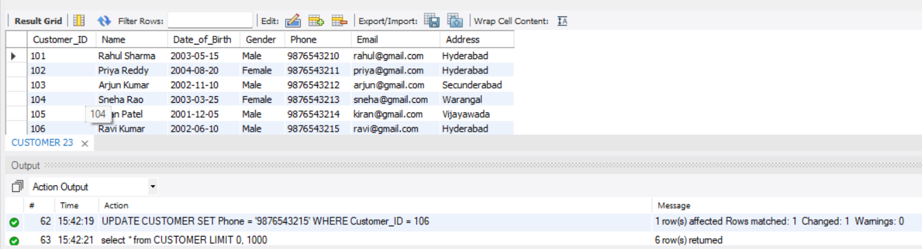

Q2. Update a customer's phone number (UPDATE)
UPDATE CUSTOMER
SET Phone = '9876543220'
WHERE Customer_ ID = 106;
Output:
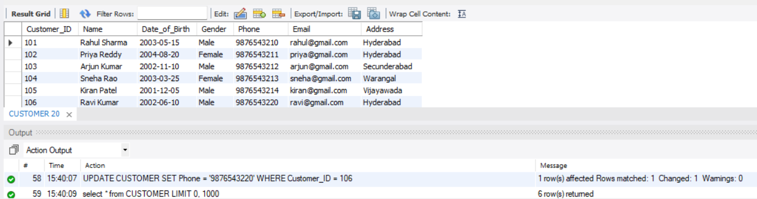

Q3. Remove a customer record (DELETE)
DELETE FROM CUSTOMER
WHERE Customer_ ID = 106;
Output:
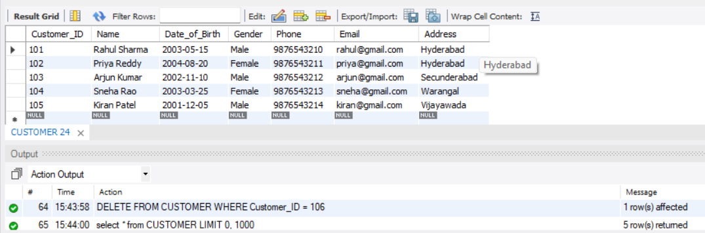

9.2 Joins :

Q4. Display customer names along with their account details (INNER JOIN)
SELECT C. Name AS Customer_ Name,
A. Account_ Number,
A. Account_ Type,
A. Balance
FROM CUSTOMER C
JOIN ACCOUNT A
ON C. Customer_ ID = A. Customer_ ID;
Output: 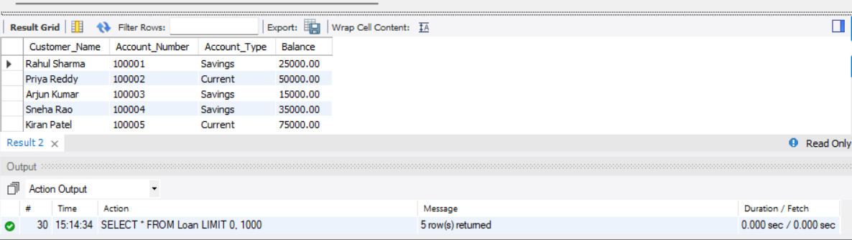
Q5. Display account details along with branch information (EQUI JOIN)
SELECT A. Account_ Number,
A. Account_ Type,
A. Balance,
B. Branch_ Name,
B. City
FROM ACCOUNT A
JOIN BRANCH B
ON A. Branch_ ID = B. Branch_ ID;
Output:
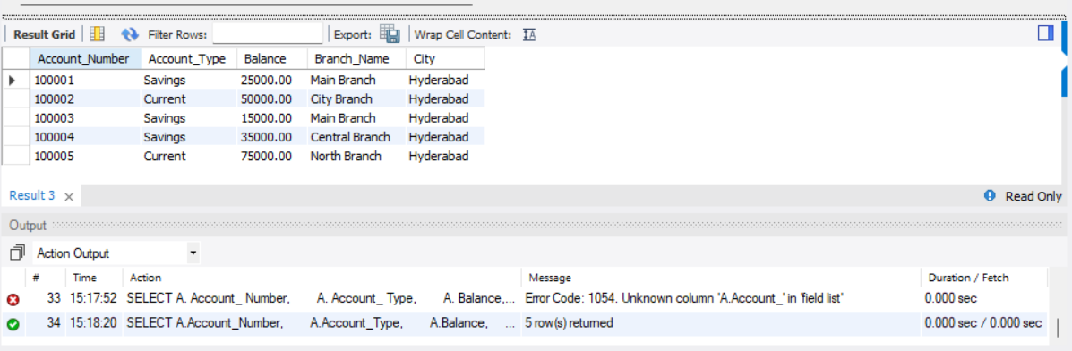

Q6. Display all customers with their account details, including customers without accounts (LEFT JOIN)
SELECT C. Customer_ ID,
C. Name,
A. Account_ Number,
A. Account_ Type,
A. Balance
FROM CUSTOMER C
LEFT JOIN ACCOUNT A
ON C. Customer_ ID = A. Customer_ ID;
Output:
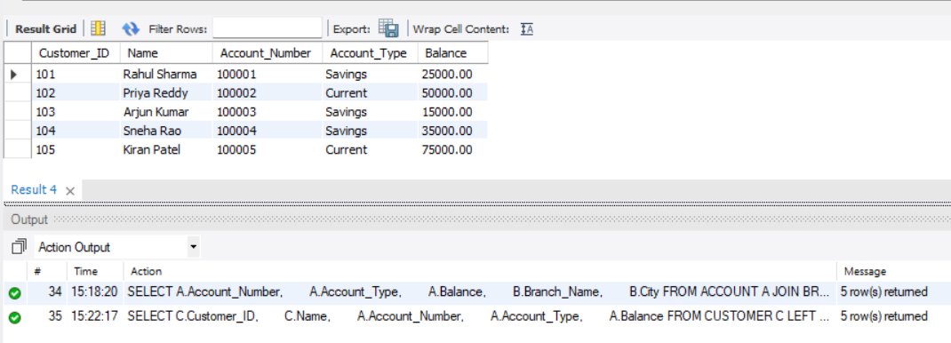

Q7. Display employees along with their branch names (INNER JOIN)
SELECT E. Employee_ ID,
E. Employee_ Name,
E. Designation,
B. Branch_ Name
FROM EMPLOYEE E
JOIN BRANCH B
ON E. Branch_ ID = B. Branch_ ID;
Output:
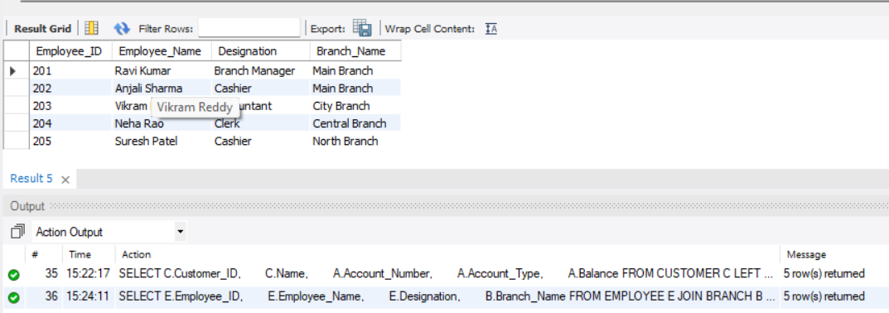

9.3 Aggregation & Grouping :
Q8. Display total balance for each account type
SELECT Account_ Type,
COUNT (*) AS Total_ Accounts,
SUM(Balance) AS Total_ Balance
FROM ACCOUNT
GROUP BY Account_ Type;
Output:
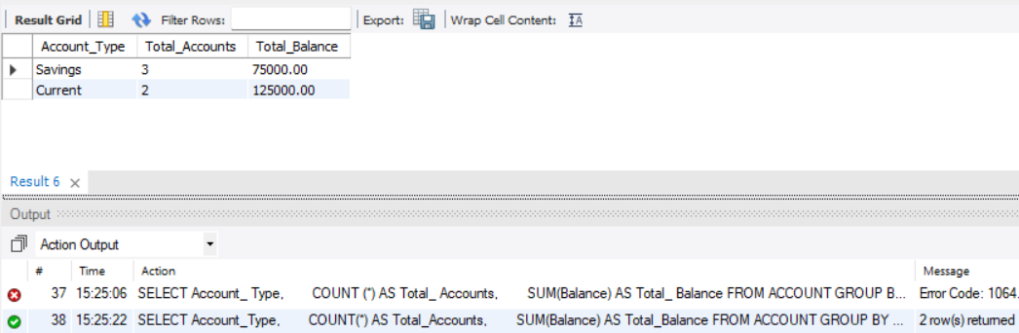

Q9. Display average transaction amount for each transaction type
SELECT Transaction_ Type,
COUNT (Transaction_ ID) AS Number_ Of_ Transactions,
AVG(Amount) AS Average_ Amount
FROM BANK_TRANSACTION
GROUP BY Transaction_ Type;
Output:
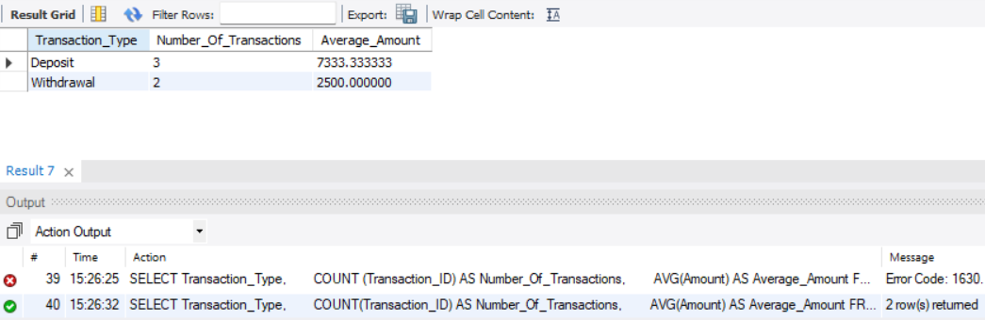

Q10. Display account types whose total balance exceeds 50000
SELECT Account_ Type,
SUM(Balance) AS Total_ Balance
FROM ACCOUNT
GROUP BY Account_ Type
HAVING SUM(Balance) > 50000;
Output:
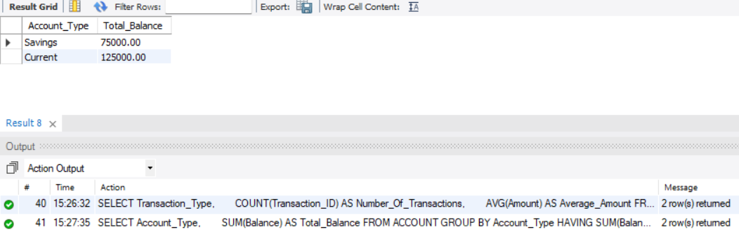

9.4 Sub query :
Q11. Display accounts whose balance is greater than the average account balance
SELECT Account_ Number,
Account_ Type,
Balance
FROM ACCOUNT
WHERE Balance > (
SELECT AVG(Balance)
FROM ACCOUNT
);
Output:
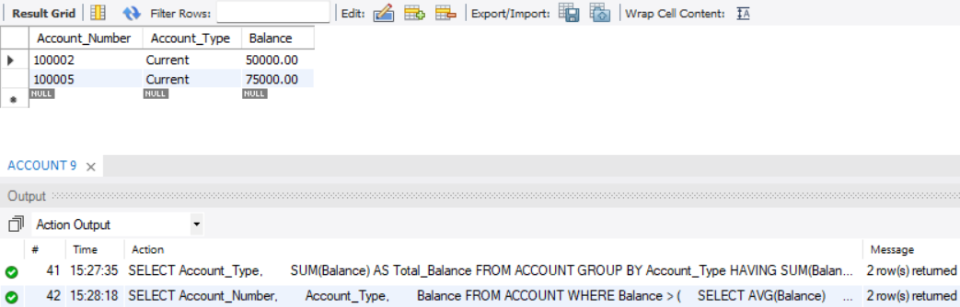

Q12. Display customers whose loan amount is greater than the average loan amount
SELECT Customer_ ID,
Name
FROM CUSTOMER
WHERE Customer_ ID IN (
SELECT Customer_ ID
FROM LOAN
WHERE Loan_ Amount > (
SELECT AVG (Loan_ Amount)
FROM LOAN
)
);
Output:
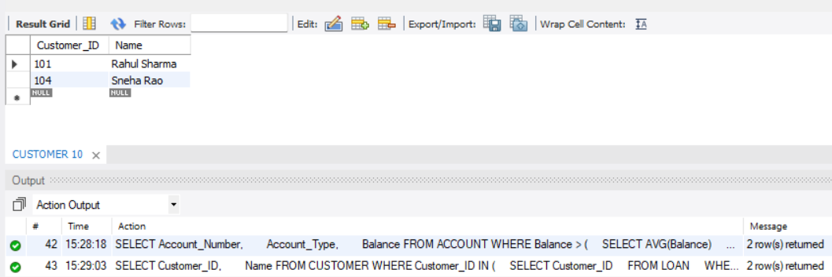

9.5 View:
Q13. Create a view combining customer, account and branch details
CREATE VIEW Customer_ Account_ View AS
SELECT
C. Name AS Customer_ Name,
A. Account_ Number,
A. Account_ Type,
A. Balance,
B. Branch_ Name,
B. City
FROM CUSTOMER C
JOIN ACCOUNT A
ON C. Customer_ ID = A. Customer_ ID
JOIN BRANCH B
ON A. Branch_ ID = B. Branch_ ID;
Output:
Message
0 row(s) affected

Q14. Display records from the customer account view
SELECT *
FROM Customer_ Account_ View;
Output:
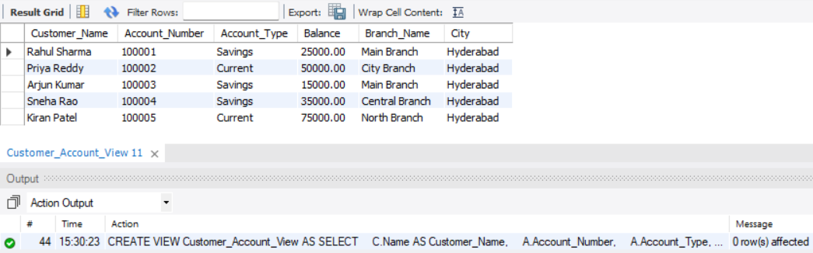

9.6 Additional Queries

Q15. Display all customers
SELECT *
FROM CUSTOMER;
Output: 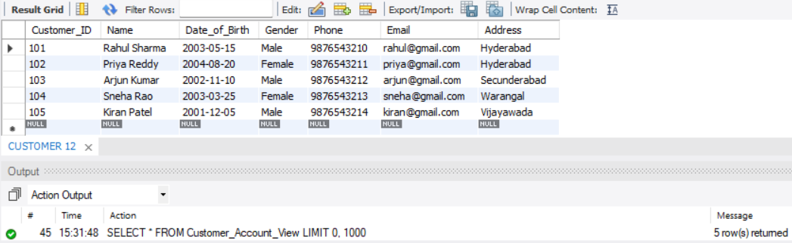

Q16. Display all active accounts
SELECT Account_ Number,
Account_ Type,
Balance,
Account_ Status
FROM ACCOUNT
WHERE Account_ Status = 'Active';
Output:
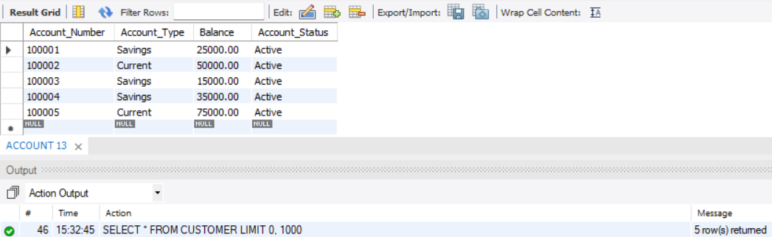

Q17. Display accounts with balance greater than 30000
SELECT Account_ Number,
Account_ Type,
Balance
FROM ACCOUNT
WHERE Balance > 30000;
Output:
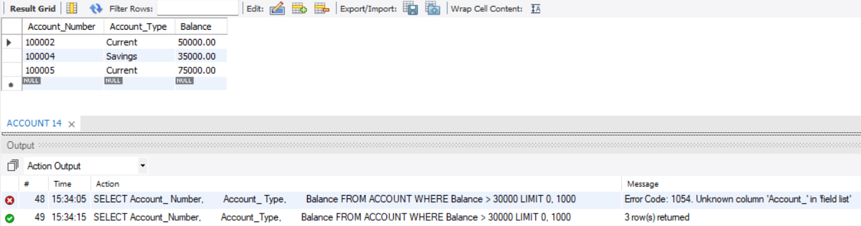
Q18. Display all loans with interest rate above 9%
SELECT Loan_ ID,
Loan_ Type,
Loan_ Amount,
Interest_ Rate
FROM LOAN
WHERE Interest_ Rate > 9;
Output:
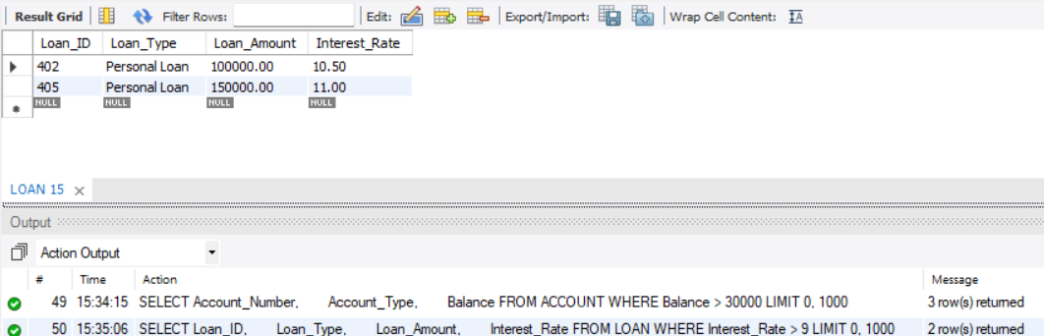
Q19. Display all successful transactions
SELECT Transaction_ ID,
Account_ Number,
Transaction_ Type,
Amount,
Transaction_ Date
FROM BANK_TRANSACTION
WHERE Status = 'Success';
Output:
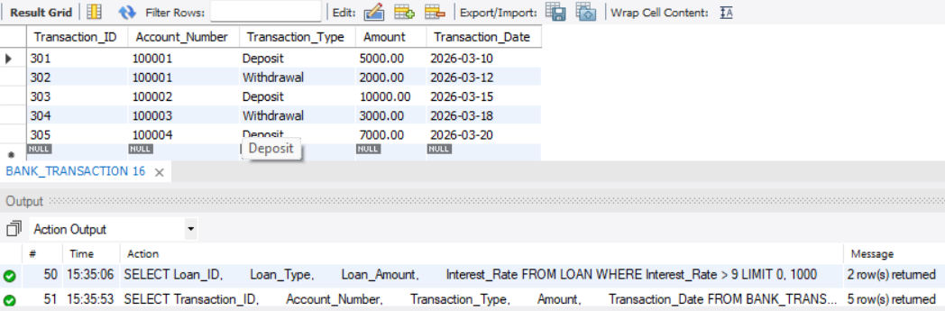

Q20. Display accounts in descending order of balance
SELECT Account_ Number,
Account_ Type,
Balance
FROM ACCOUNT
ORDER BY Balance DESC;
Output:
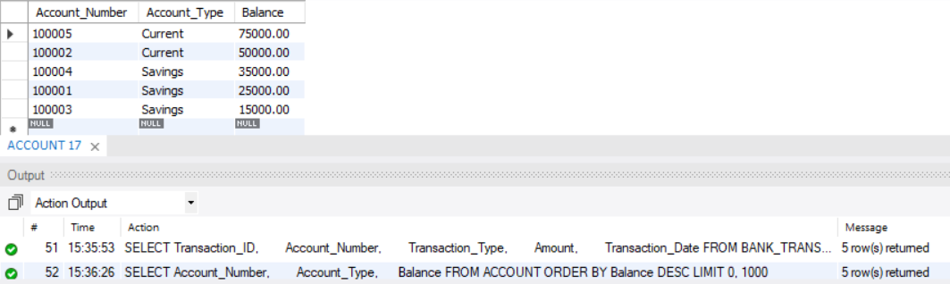

Q21. Display number of employees in each branch
SELECT Branch_ ID,
COUNT (*) AS Employee_ Count
FROM EMPLOYEE
GROUP BY Branch_ ID;
Output:

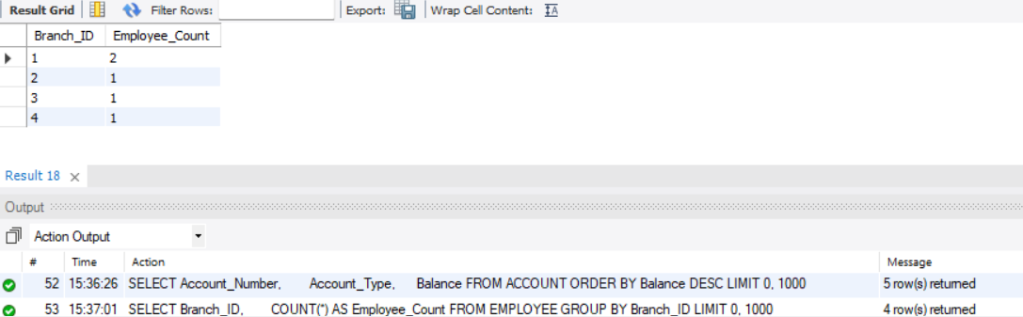

10. CONCLUSION
The Bank Account Management System provides a structured relational database solution for managing core banking information. The design organizes customers, accounts, branches, employees, transactions, and loans into six related tables and uses Primary Keys, Foreign Keys, UNIQUE, NOT NULL, and CHECK constraints to maintain data integrity. The normalization process up to 3NF reduces data redundancy and improves data consistency. The SQL implementation and query set demonstrate DDL, DML, DQL, CRUD operations, joins, aggregate functions, GROUP BY, HAVING, and a database view for retrieving and analyzing banking information. The project therefore provides a suitable DBMS implementation that can be extended into a more complete banking management application.

11. FUTURE ENHANCEMENTS
● Online Banking Integration – Connect the database with a web-based banking application for accessing account and transaction information.
● Mobile Application – Provide mobile access to customer account and transaction information.
● Fund Transfer Module – Add secure fund transfer functionality between bank accounts.
● Loan Management – Add loan approval, repayment, and tracking features.
● Reports & Analytics – Generate detailed customer, account, transaction, and loan reports.
● User Authentication – Add secure login and role-based access for customers and bank employees.
● Backup & Recovery – Implement regular database backup and recovery mechanisms.
● Audit Logging – Track important changes made to banking records for better monitoring and accountability.

REFERENCES
1. Korth, H. F., Silberschatz, A., and Sudarshan, S., Database System Concepts, McGraw Hill.
2. Elmasri, R. and Navathe, S. B., Fundamentals of Database Systems, Pearson.
3. MySQL 8.0 Reference Manual, Oracle Corporation, https://dev.mysql.com/doc/

